Overview
An ISACA chapter is created when like-minded individuals see an opportunity to formalize and expand the benefits of being in a local community, which includes connecting with others who share interests, getting involved through volunteerism, welcoming others, and raising awareness of ISACA’s mission and purpose.
ISACA chapters advance those goals and sustain a localized organization that benefits the community and the broader profession, tailored to their context.
Chapters that have adopted and sustained mature practices see better outcomes regarding member satisfaction, retention of members, growth of certification holders, and influence through advocacy efforts. However, attaining excellence takes time; it requires systematic planning and strategy development.
What is Chapter 360?
Chapter 360 is a resource for volunteer chapter leaders that simplifies the role of sustaining the organization and equips them with tools to maximize the chapter's potential. It guides volunteer leaders to consistently deliver (to their utmost abilities) ISACA's offerings throughout its area, based on local needs and using preferred practices.
Chapter 360 was inspired by the format of CMMI V 3.0® and COBIT®, which provide practices that can be tailored to achieve success for the chapter from every angle.
Why it Matters

- As a chapter follows this model, it will provide a 360° view of the chapter, uncover any unknown opportunities, gaps, or risks, and help the chapter achieve relevance, value, scalability, and trustworthiness.​
- For chapters seeking growth, developing strategies in focus areas most relevant to a chapter can increase its potential, expand its capabilities, ensure scalability, amplify its local strategy, and accelerate performance for its established goals.​
- Through the Chapter 360 self-assessment tool, ISACA Global can ensure volunteer chapter leaders have the most important and relevant resources based on their chapter’s unique needs and challenges.

How it is Organized
The Chapter 360 tool comprises six key Focus Areas, and within each Focus Area, there are three to six Practice Areas. For example:

1.0 Focus Area
Practice Areas articulate:
- What it is (definition)
- Why it Matters
- Detailed examples
- Sources of inspiration (references)
- Resources (tools)

1.3 Practice Area
1.2 Practice Area
1.1 Practice Area
The full view of Focus and Practice Areas is as follows:
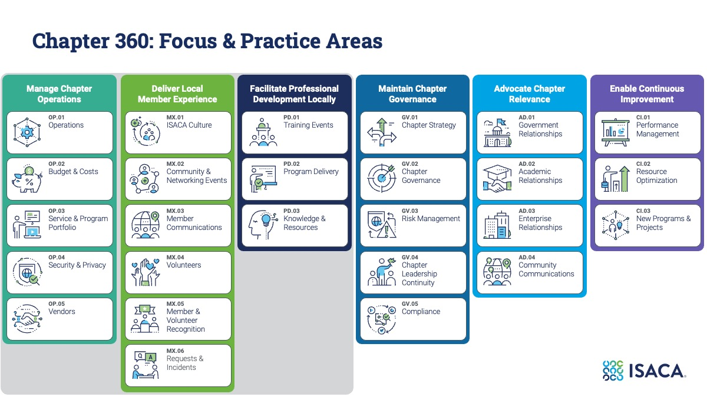
As part of the self-assessment scoring, the Focus Area “Manage Chapter Operations” is foundational to the Focus Areas “Deliver Local Member Experience” and “Facilitate Professional Development Locally.”
When you complete a self-assessment, the scores for “Deliver Local Member Experience” and “Facilitate Professional Development Locally” also will include your ratings for “Manage Chapter Operations.”

How to Self-Assess
ISACA Global will provide a link for self-assessment annually so that we can gather results and determine how to prioritize the development of resources, templates, and tools for our chapters. Upon completion of the annual assessment, your chapter’s aggregated results will be available in the document library for your chapter on Engage. As we continue the development of the Chapter 360 tool, we aim to have this integrated into the Chapter Leader Portal. Until then, you can submit your self-assessment at https://www.surveymonkey.com/r/TXN57LW

Interpreting Your Score

Once you’ve completed an assessment for your chapter, you will receive a report with the scores provided for each practice area and rolled up into the overall focus area. If one or more leaders from your chapter have taken the survey independently, the scores will be averaged into one final score. The scoring method is straightforward and simple:

- Each practice area is assessed on a scale of 1 to 5. (Visual below)
- Focus area scores are an average of the practice area scores it includes. Please note: the scores for Deliver Local Member Experience and Facilitate Professional Development Locally will also include your ratings for Manage Chapter Operations.
- Your chapter’s overall score is an average of all practice area scores.

